**Getting Started with Amazon Glacier**

**Introduction**

**What Is Amazon Glacier?**

Amazon Glacier is an extremely low-cost storage service that provides durable storage with security features for data archiving and backup. With Amazon Glacier, customers can store their data cost effectively for months, years, or even decades. Amazon Glacier enables customers to offload the administrative burdens of operating and scaling storage to AWS, so they don't have to worry about capacity planning, hardware provisioning, data replication, hardware failure detection and recovery, or time-consuming hardware migrations**.**

**Before You Begin with Amazon Glacier**

**Sign Up**

**To sign up for an AWS account**

1. Open https://aws.amazon.com/, and then choose **Create an AWS Account**.
2. **Note**
3. This might be unavailable in your browser if you previously signed into the AWS Management Console. In that case, choose **Sign In to the Console**, and then choose **Create a new AWS account**.
4. Follow the online instructions.
5. Part of the sign-up procedure involves receiving a phone call and entering a PIN using the phone keypad.
6. **Download the Appropriate AWS SDK**

The getting started exercise provides examples in Java and C#.

**Downloading the AWS SDK for Java**

To test the Java examples in this developer guide, you need the AWS SDK for Java. You have the following download options:

If you are using Eclipse, you can download and install the AWS Toolkit for Eclipse using the update site http://aws.amazon.com/eclipse/. If you are using any other IDE to create your application, download the AWS SDK for Java .

**Downloading the AWS SDK for .NET**

To test the C# examples in this developer guide, you need the AWS SDK for .NET. You have the following download options:

If you are using Visual Studio, you can install both the AWS SDK for .NET and the AWS Toolkit for Visual Studio. The toolkit provides AWS Explorer for Visual Studio and project templates that you can use for development.

Go to <http://aws.amazon.com/sdkfornet> and click **Download AWS SDK for .NET**. By default, the installation script installs both the AWS SDK and the AWS Toolkit for Visual Studio.

If you are using any other IDE to create your application, you can use the same link provided in the preceding step and install only the AWS SDK for .NET.

**Create a Vault in Amazon Glacier**

**What is a Vault.**

A vault is a container for storing archives. Your first step is to create a vault in one of the supported AWS regions. In this getting started exercise, you create a vault in the US West (Oregon) region.

**Creating a Vault.**

1. Sign into the AWS Management Console and open the Amazon Glacier console at https://console.aws.amazon.com/glacier/.
2. Select a region from the region selector.
3. In this getting started exercise, we use the US West (Oregon) region.
4. If you are using Amazon Glacier for the first time, click Get started. (Otherwise, you would click Create Vault.)
5. Enter examplevault as the vault name in the Vault Name field and then click Next Step.
6. Select Do not enable notifications. For this getting started exercise, you will not configure notifications for the vault.
7. If the region and vault name are correct, then click Submit.
8. Your new vault is listed on the Amazon Glacier Vaults page.

**Upload an Archive to a Vault in Amazon Glacier**

**What is Archive.**

An archive is any object, such as a photo, video, or document that you store in a vault. It is a base unit of storage in Amazon Glacier. You can upload an archive in a single request. For large archives, Amazon Glacier provides a multipart upload API that enables you to upload an archive in parts.

**Upload an Archive to a Vault in Amazon Glacier Using the AWS SDK for Java**

* The following Java code example uses the high-level API of the AWS SDK for Java to upload a sample archive to the vault. In the code example, note the following:
* The example creates an instance of the Amazon Glacier Client class.
* The example uses the upload method of the Archive Transfer Manager class from the high-level API of the AWS SDK for Java.
* The example uses the US West (Oregon) region (us-west-2) to match the location where you created the vault previously in Step 2: Create a Vault in Amazon Glacier.

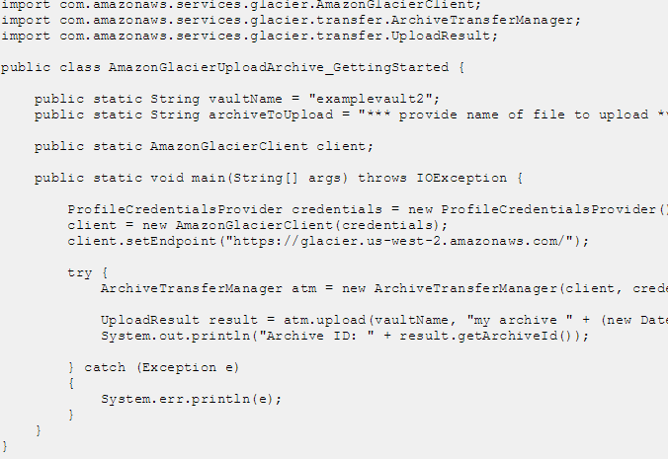

**Upload an Archive to a Vault in Amazon Glacier Using the AWS SDK for .NET**

**The following C# code example uses the high-level API of the AWS**

SDK for .NET to upload a sample archive to the vault. In the code example, note the following:

The example creates an instance of the ArchiveTransferManager class for the specified Amazon Glacier region endpoint.

The code example uses the US West (Oregon) region (us-west-2) to match the location where you created the vault previously in Step 2: Create a Vault in Amazon Glacier.

The example uses the Upload method of the ArchiveTransferManager class to upload your archive. For small archives, this method uploads the archive directly to Amazon Glacier. For larger archives, this method uses Amazon Glacier's multipart upload API to split the upload into multiple parts for better error recovery, if any errors are encountered while streaming the data to Amazon Glacier.

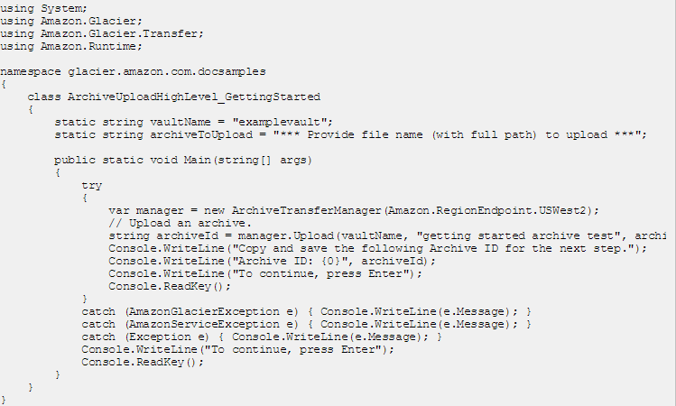

**Delete an Archive from a Vault in Amazon Glacier**

**Delete an Archive from a Vault in Amazon Glacier Using the AWS SDK for Java**

The following code example uses the AWS SDK for Java to delete the archive.

In the code, note the following:

The Delete Archive ssRequest object describes the delete request, including the vault name where the archive is located and the archive ID.

The delete Archive method sends the request to Amazon Glacier to delete the archive.

The example uses the US West (Oregon) region (us-west-2) to match the location where you created the vault in Step 2: Create a Vault in Amazon Glacier.

**Delete an Archive from a Vault in Amazon Glacier Using the AWS SDK for .NET**

* The following C# code example uses the high-level API of the AWS SDK for .NET to delete the archive you uploaded in the previous step. In the code example, note the following:
* The example creates an instance of the Archive Transfer Manager class for the specified Amazon Glacier region endpoint.
* The code example uses the US West (Oregon) region (us-west-2) to match the location where you created the vault previously in Step 2: Create a Vault in Amazon Glacier.

The example uses the Delete method of the Archive Transfer Manager class provided as part of the high-level API of the AWS SDK for .NET

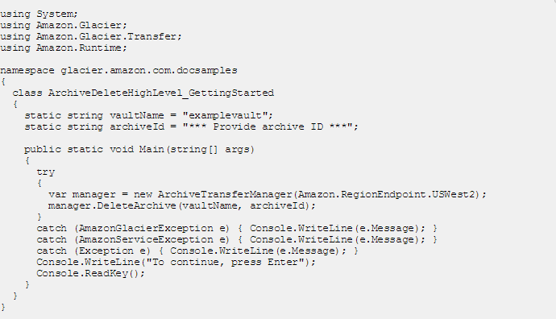

**Delete a Vault in Amazon Glacier**

A vault is a container for storing archives. You can delete an Amazon Glacier vault only if there are no archives in the vault as of the last inventory that Amazon Glacier computed and there have been no writes to the vault since the last inventory.

**To delete a vault**

Sign into the AWS Management Console and open the Amazon Glacier console at https://console.aws.amazon.com/glacier.

From the region selector, select the AWS region where the vault exists that you want to delete.

In this getting started exercise, we use the US West (Oregon) region.

Select the vault that you want to delete.

In this getting started exercise, we've been using a vault named **examplevault**.

Click **Delete Vault**.